House Mate Controller Design Document

*NOTE: Text in italics should be replaced with your own content.*

Date: 10/20/2015

Author: Gerald Trotman

Reviewer(s):

# Introduction

This document defines the design for the House Mate Controller Service API, a model that centralizes and implements commands

Overview

*Overview of the problem to be solved. What is the problem and why is it being solved? How will the resulting solution provide business value?*

*Consider adding a diagram that explains how this component fits into the overall System with some descriptive text explaining the diagram.*

# Requirements

*This section defines the requirements for the Mobile Application Store Product API.*

*Provide your understanding of the requirements, both functional and nonfunctional. Reference the provided Requirements and System Architecture documents. Don’t cut and paste from the requirements document.*

*Product Manager and others can read this to understand what requirements your design will support. There is already a requirements doc, so keep this brief and to the point, highlighting the important requirements that the design is addressing. Structure in a way to provide a requirements checklist for your design.*

# Use Cases

*Enumerate the use cases supported by the design,*

*This design supports the following use cases:*

*Include a Use Case Diagram.*

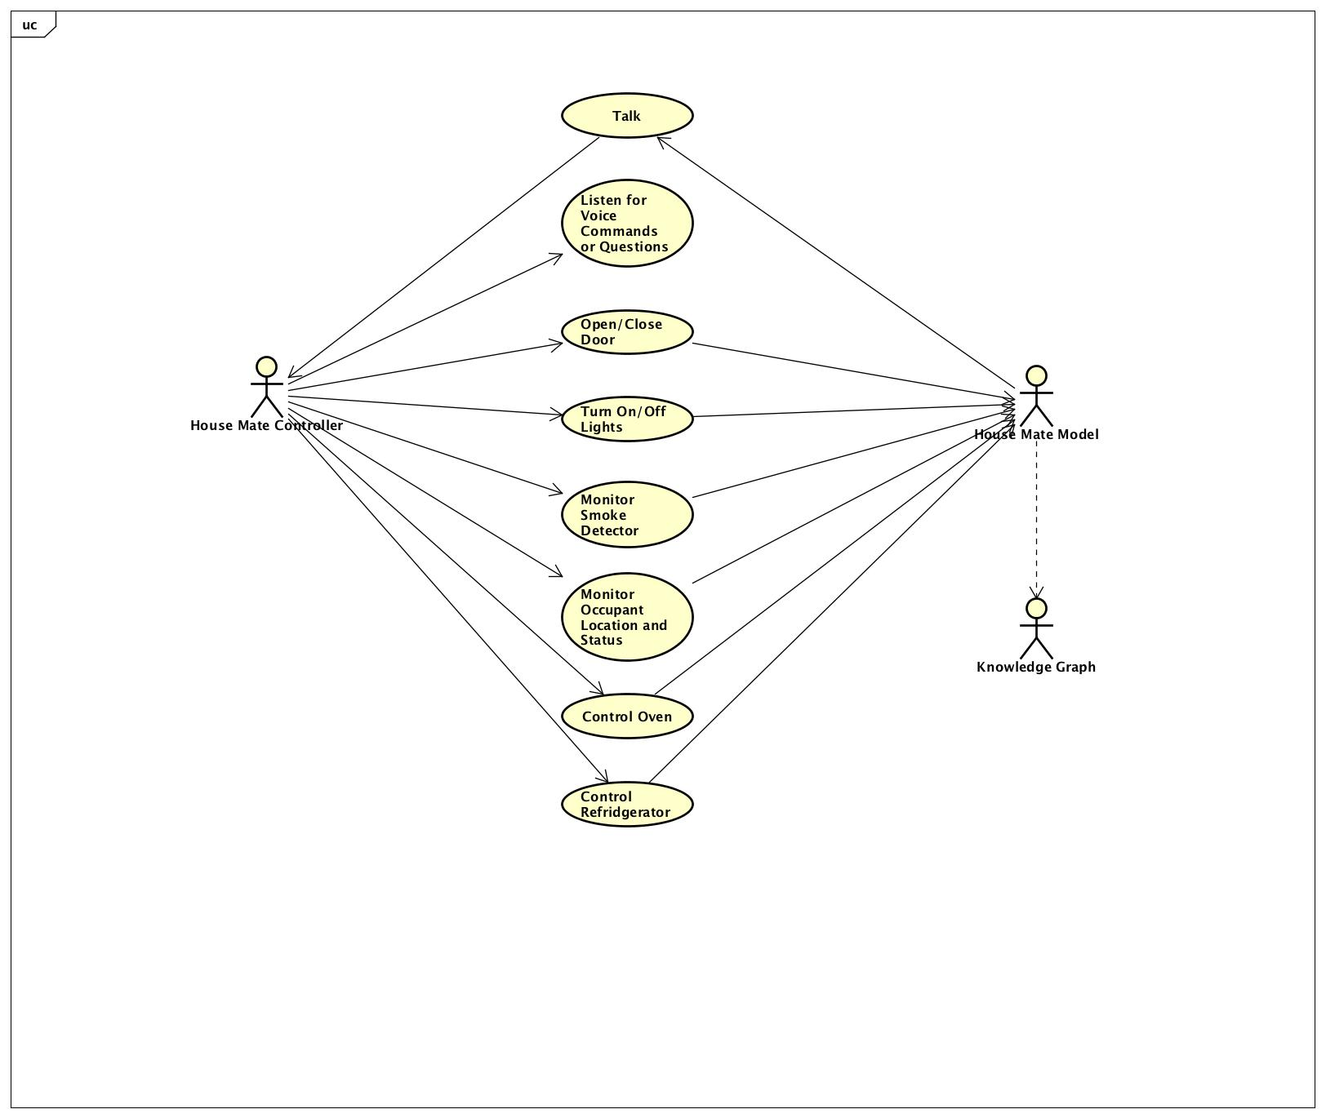

# Implementation

*This section of the document will describe the implementation details for ...*

*The implementation section should cover the following topics:*

* *What are the classes, and their properties, associations and methods?*
* *What are the important interfaces and how they will be implemented?*
* *How are the requirements addressed?*

# Class Diagram

*The following class diagram defines the classes defined in this design.*

*CLASS DIAGRAM GOES HERE*

# Class Dictionary

*This section specifies the class dictionary for the class … defined within the package …*

## *Command <interface>*

*Class 1 description*

***Methods***

|  |  |  |
| --- | --- | --- |
| **Method Name** | **Signature** | **Description** |
| execute |  |  |

***Properties***

|  |  |  |
| --- | --- | --- |
| **Property Name** | **Type** | **Description** |
|  |  |  |

***Associations***

|  |  |  |
| --- | --- | --- |
| **Association Name** | **Type** | **Description** |
|  |  |  |

## *CLASS 2*

***Methods***

|  |  |  |
| --- | --- | --- |
| **Method Name** | **Signature** | **Description** |
|  |  |  |

***Properties***

|  |  |  |
| --- | --- | --- |
| **Property Name** | **Type** | **Description** |
|  |  |  |

***Associations***

|  |  |  |
| --- | --- | --- |
| **Association Name** | **Type** | **Description** |
|  |  |  |

***Methods***

|  |  |  |
| --- | --- | --- |
| **Method Name** | **Signature** | **Description** |
|  |  |  |

***Properties***

|  |  |  |
| --- | --- | --- |
| **Property Name** | **Type** | **Description** |
|  |  |  |

***Associations***

|  |  |  |
| --- | --- | --- |
| **Association Name** | **Type** | **Description** |
|  |  |  |

# Implementation Details

*Explain details of the implementation.*

*How do the various parts fit together or interact?*

*For example:*

* *How are Feature instances created and managed?*
* *How is the management interface implemented?*
* *How are the features used to generated functional code?*

*Some implementation details may be addressed in the class dictionary, but for things that are not, describe them here.*

*Remember to reference the requirements from the body of the design document to show how your design is addressing the requirements.*

# Testing

*Provide a testing strategy for testing the component.*

* *Functional*
* *Performance*
* *Regression*
* *Exception Handling*

# Risks

*Document any risks identified during the design process.*

*Are there parts of the design that may not work or need to be implemented with special care or additional testing?*